1. Technet

Identify and fix any network connectivity problems

To resolve this issue, identify and fix any network connectivity problems between the‚ DHCP server and domain controller by doing the following:

* Determine if there is a network connectivity problem by using the ping command.
* Perform additional troubleshooting steps, if necessary, to help identify the cause of the problem.

To perform these tasks, refer to the following sections.

**Note:**The following procedures include steps for using the ping command to perform troubleshooting. Therefore, before performing these steps, check whether the firewall or Internet Protocol security (IPsec) settings on your network allow Internet Control Message Protocol (ICMP) traffic. ICMP is the TCP/IP protocol that is used by the ping command.

To perform these procedures, you must have membership in the local **Administrators** group, or you must have been delegated the appropriate authority.

**Determine if there is a network connectivity problem**

To determine if there is a network connectivity problem between the‚ DHCP‚ server and domain controller:

1. At the DHCP server, click **Start**, click **Run**, type **cmd**, and then click **OK**.
2. At the command prompt, type **ping *server_FQDN***, where *server_FQDN* is the fully qualified domain name (FQDN) of the domain controller (for example, server1.contoso.com), and then press ENTER.

If the ping was successful, you will receive a reply similar to the following:

Reply from IP_address: bytes=32 time=3ms TTL=59

Reply from IP_address: bytes=32 time=20ms TTL=59

Reply from IP_address: bytes=32 time=3ms TTL=59

Reply from IP_address: bytes=32 time=6ms TTL=59

1. At the command prompt, type **ping *IP_address***, where *IP_address* is the IP address of the domain controller, and then press ENTER.

If you can successfully ping the domain controller by IP address, but not by FQDN, this indicates a possible issue with DNS host name resolution.

If you cannot successfully ping the domain controller by IP address, this indicates a possible issue with network connectivity, firewall configuration, or IPsec configuration.

**Perform additional troubleshooting steps**

The following are some additional troubleshooting steps that you can perform to help identify the root cause of the problem:

* Ping other computers on the network to help determine the extent of the network connectivity issue.
* If you can ping other servers but not the domain controller, try to ping the domain controller from another computer. If you cannot ping the domain controller from any computer, first ensure that the domain controller is running. If the domain controller is running, check the network settings on the domain controller.
* Check the TCP/IP settings on the local computer by doing the following:

1. Click **Start**, click **Run**, type **cmd**, and then click **OK**.
2. At the command prompt, type **ipconfig /all**, and then press ENTER. Make sure that the information listed is correct.
3. Type **ping localhost** to verify that TCP/IP is installed and correctly configured on the local computer. If the ping is unsuccessful, this may indicate a corrupt TCP/IP stack or a problem with your network adapter.
4. Type **ping *IP_address***, where *IP_address* is the IP address assigned to the computer. If you can ping the localhost address but not the local address, there may be an issue with the routing table or with the network adapter driver.
5. Type **ping *DNS_server***, where *DNS_server* is the IP address assigned to the DNS server. If there is more than one DNS server on your network, you should ping each one. If you cannot ping the DNS servers, this indicates a potential problem with the DNS servers, or with the network between the computer and the DNS servers.
6. If the domain controller is on a different subnet, try to ping the default gateway. If you cannot ping the default gateway, this might indicate a problem with the network adapter, the router or gateway device, cabling, or other connectivity hardware.

* In Device Manager, check the status of the network adapter. To open Device Manager, click **Start**, click **Run**, type **devmgmt.msc**, and then click **OK**.
* Check network connectivity indicator lights on the computer and at the hub or router. Check network cabling.
* Check firewall settings by using the Windows Firewall with Advanced Security snap-in.
* Check IPsec settings by using the IP Security Policy Management snap-in.

Verify

To verify that the computer has a valid lease:

1. At the DHCP-enabled client computer, click **Start**, in **Start Search** type **cmd**, and then press ENTER.
2. To verify a DHCP client lease, type **ipconfig /all** to view lease-status information.
3. The output of the **ipconfig** command should show an IPv4 or IPv6 address marked "preferred."
4. Best Answer

I resolved the same issue by disabling my Wireless Connection #2 (Microsoft Virtual WiFi Miniport Adaptor) network adapter.  I found this by comparing the MAC address listed in the error message with the output of CMD>ipconfig /all.  Noticed that this adapter continuously tried to communicate with my DHCP server, and I wasn't even using it.

1. Microsoft Support

**Method 1**

I would suggest that you disable the Internet Protocol Version 6(IPv6) on the network adapter and check if it helps.

a.     Right click on the Network icon in the System Tray and click on Network and Sharing center.

b.     Click on Change Adapter settings.

c.     Right click on Network Adapter and Choose ‘Properties’.

d.     Uncheck “Internet Protocol Version 6”.

e.     Click on OK.

**Note**: By disabling IPv6, you will not be able to use Windows Meeting Space or any application that relies on the Windows Peer-to-Peer Networking platform

**Method 2**

If the above step fails then I would suggest that you update the firmware of the router or modem by visiting the manufacturer website and also update the driver for the network adapter on the computer, check if it helps.

1. 3 people found helpful

try this method

on the command prompt which you should run as under administrator login type

the following:

route delete 0.0.0.0

and then

ipconfig /renew

1. Event 1003 Technet

## Resolve

### Start the DHCP Server service

On the DHCP server, configure the DHCP Server service to start automatically, and then start the service.

To perform these procedures, you must be a member of the **Administrators** group, or you must have been delegated the appropriate authority.

To configure the DHCP Server service to start automatically:

1. At the DHCP server computer, click **Start**, click **Run**, type **services.msc**, and then click **OK**.
2. Double-click **DHCP Server**.
3. On the **General** tab, in the **Startup** type box, click **Automatic**, and then click **Apply**.
4. Click **Start**, wait for the progress bar to complete, and then click **OK**.
5. On the **File** menu, click **Exit**.

## Verify

To verify that the computer has a valid lease:

1. At the DHCP-enabled client computer, click **Start**, in **Start Search** type **cmd**, and then press ENTER.
2. To verify a DHCP client lease, type **ipconfig /all** to view lease-status information.
3. The output of the **ipconfig** command should show an IPv4 or IPv6 address marked "preferred."
4. Windows 8 – Code 52
5. Go to control panel.
6. Then device manager.
7. Click Net work adaptor.
8. Click Qualcomm Atheros AR9485 802. 11b/g/n WiFi Adaptor.
9. Choose driver tab.
10. Choose update drive.
11. Choose browse my computer for driver software.
12. Choose let me pick from a list of device drivers on my computer.
13. Select the original/pervious WiFi Adaptor before the airplane mode lighted stayed orange.

**Case**

In my case, my problem was the adaptor with the forward slashes“11b/g/n” that “Windows couldn’t verify the digital signature for drivers”.  See example below.

Qualcomm Atheros AR9485 802. 11b/g/n WiFi Adaptor

Qualcomm Atheros AR9485 802. **11b|g|n** WiFi Adaptor

After selecting the original driver WiFi Adaptor with the slashes or**|** mark**“11b|g|n”.**I instantly had WiFi connections and was able to key in my password to connect to my Network. So now I  provide you  this solution.

No need to reboot.

This will work.

7. Run a damned system restore

8. Hardware Solution

1. Make sure that all cables are connected (for example, make sure your modem is connected to a working phone jack or cable connection, either directly or through a router).
2. Restart your modem, and then restart your router. Remove the power cable from the modem and router. After all lights on the device have gone out, wait at least 10 seconds, and then plug the modem and router back in. Some modems have a battery backup that prevents the lights from going out. For this type of modem, press and quickly release the Reset button. If you don’t see a Reset button, remove the battery instead.

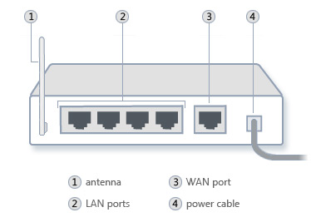The back of a router, showing the location of the power cable

1. Check your router. Because of the new networking features in Windows Vista and Windows 7, some older network routers are not fully compatible with these versions of Windows and can cause problems. For a list of routers that are compatible with Windows Vista, go to the [**Windows Compatibility Center**](http://go.microsoft.com/fwlink/?linkid=140306) website.

8. Windows 10 Insider – 278 found helpful

I agree that it may be a winsock or tcp/ip problem. Run the following; only need to restart the system after running all three commands.

**TCP/IP stack repair options for use with Vista and 7 and 8 and 10.**  
  
Start - All Programs - Accessories and right click on Command Prompt, select "Run as Administrator" to open a command prompt. [For Windows 8 or 10: <Windows Logo> + x - Command Prompt(Admin)]  
  
Reset WINSOCK entries to installation defaults: **netsh winsock reset catalog**  
  
Reset IPv4 TCP/IP stack to installation defaults. **netsh int ipv4 reset reset.log**  
  
Reset IPv6 TCP/IP stack to installation defaults. **netsh int ipv6 reset reset.log**  
  
Reboot the machine.

8.5. Windows 10 Insider – 10 people found help – Alternative Solution from same user

Use dynamic (Dhcp) addressing and…

Open a (black) Command Prompt window:  
Hold the [B]Windows logo[/B] key and press [B]r[/B]; in the Run box type [B]cmd[/B] and click on [B]OK[/B].  
  
Type the following command:  
  
[B]IPCONFIG /ALL[/B]  
  
[Note that there is no space between the slash and ALL.]  
  
[Press ENTER after each command.]  
  
Right click in the command window and choose [B]Select All[/B], then hit [B]Enter[/B].  
Paste the results in a message here.  
  
If necessary use a text file and removable media to copy the results to a computer with internet access.

9 – 9 solutions

Recently, I was helping a client with Windows 7 who was unable to connect to his home wireless network one day even though it had been working fine for a few months. When he went to Network and Sharing Center, he had the following listed:

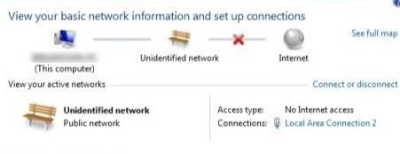

Instead of his normal network connection, it said **Unidentified Network** and **No Internet Access**and sure enough, he could not connect to the Internet! The same thing showed up in the taskbar icon for network connections:

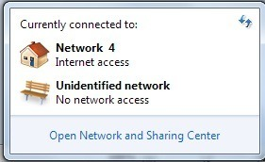

I’ve seen this problem on a couple of Windows 7 machines and depending on your system, there are multiple possible solutions. Try each one listed below and check to see if it fixe your problem before moving on.

### Method 1 – Disable McAfee Network Agent

One common culprit has been the McAfee Network Agent service. You can disable the service by going to **Start**, typing in **MSCONFIG** and then clicking on the **Services** tab. Find McAfee Network Agent and uncheck the box.

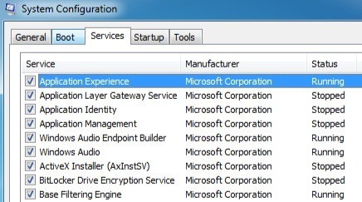

It also might be a good idea to disable any third-party firewall like McAfee firewall or Norton firewall, etc.

### Method 2- Update Your Network Card Driver

You can update your driver in one of two ways: either via Windows or by downloading the driver yourself manually from the manufacture’s website. I highly recommend downloading the latest driver yourself as Windows usually does not do a very good job, but here are the instructions in case you want to try it.

Click on **Start**, type in **devmgmt.msc**, press Enter and then expand Network Controllers and right-click on the problem network card.

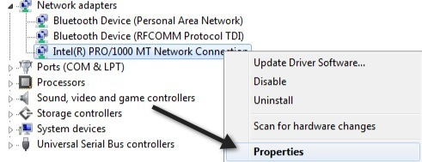

Now click on the **Driver** tab and choose **Update Drive**r.

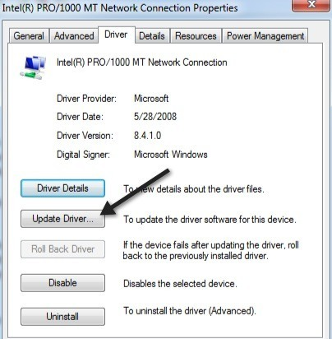

If that doesn’t work, you can also uninstall the network driver and then reinstall it after a restart. This has also been known to fix the problem with some people. Note that Windows will automatically reinstall the driver for you. In case it does not, you can always download the latest driver and then install it.

### Method 3 – Restart Your Router and Modem

Just in case, make sure you restart your wireless router and your modem because you’ll waste a lot of time messing with your computer for no reason if it’s actually a problem with the router.

### Method 4 – Reset TCP/IP Stack

You can try to reset your network settings and fix any problems with the TCP/IP stack by running the Microsoft FixIt solution here:

<http://support.microsoft.com/kb/299357>

### Method 5 – Upgrade Router Firmware

If nothing else has worked so far, try upgrading the firmware on your router. This is a slightly more technical process because you have to connect to your router via a web browser, but a little searching on Google will give you step by step directions. It’s a fairly easy process and might solve your problem, especially if you have an older router or have had one for a long time and have never updated the firmware.

### Method 6 – Use One Connection or Bridge Connections

If you have both an Ethernet connection enabled and a wireless connection on your laptop or desktop, that could be the cause of the problem. You can either try disconnecting one, restarting and then seeing if you can get Internet access for each individually or you can try to bridge the connections.

You can do this by going to **Network and Sharing Center**, click on **Change Adapter Settings**, then select both the**Local Area Connection** and the**Wireless Network Connection**and right-click on either one. You will see the option to **Bridge Connections**.

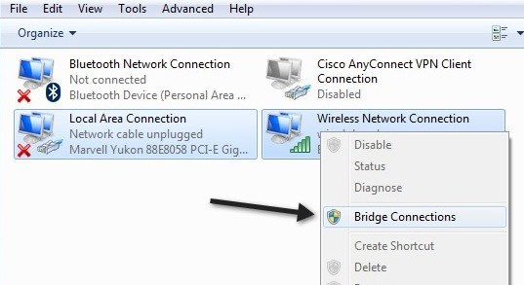

Doing this can fix the problem of both networks conflicting with each other. Give it a shot if nothing else has worked until now. You can always unbridge the connections later on if you like.

### Method 7 – Check Adapter Settings

This solution is a little trick because it can be something random, but you need to go to**Network and Sharing Center**, click on**Change Adapter Settings**, then right-click on Local Area Connection or Wireless Network Connection and choose **Properties**.

You’ll see a box that says **This connection uses the following items**, which contains a list of protocols used by the network card to communicate. It should look something like this:

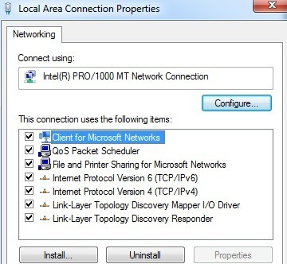

Now if you installed some network related software like VPN software or something like that, you might have some strange extra stuff listed in there. You need to uninstall those items and basically have something that looks like the list above. Once those are removed, restart and see it that solves your problem.

### Method 8 – Disable Virtual Ethernet Adapters

If you have VMWare or any other virtual machine software installed, go to Device Manager and disable any virtual network adapters that may appear there under Network Controllers. You won’t be able to connect to the Internet from your virtual machine, but you can always re–enable them for that. If the problem goes away though, it might be worth upgrading to the latest version of the virtual machine software to see if it’s more compatible with Windows 7.

### Method 9 – Enable/Disable Network Connection

You can go to Network and Sharing Center, click on **Change Adapter Settings**and then right-click on the network adapter and choose **Disable**. Wait a little while and then re-enable the network connection.

That’s all the solutions I could find for fixing this problem. If you still have unidentified network with no Internet access, then post your specs here and we’ll try to help! Enjoy!

10. Advertisement Website

If the “unidentified network” message pops up every time you start your PC and you have no internet access, here’s a quick tutorial that will help you to fix this issue:

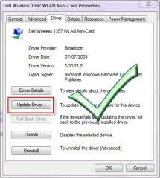

## Possible problems:

* CS3 Bonjour Service
* 0.0.0.0 gateway
* Old drivers

## Delete 0.0.0.0 Gateway To Fix Unidentified Network Issue

**1. Step** [**Open an elevated command prompt**](http://windows7themes.net/how-to-open-elevated-command-prompt-in-windows-7.html) (click link for explanation)

**2. Step** Enter delete route 0.0.0.0

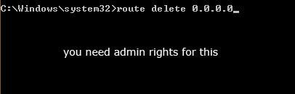

**3. Step** Hit enter and reboot

## Winsock Fix: Reset Catalog To Fix Unidentified Network Issue

We previously had a lot of network issues, that’s why we wrote a handy bat file, a “winsock fix” that will reset your net catalog.

You can [**download the Winsockfix here**](http://windows7themes.net/winsock-fix-for-windows-7.html)

## Last Resort: Update Network Driver

Update the network driver. You will need to figure out what network adapter you use and download the correct driver, then follow the steps below.

**(1)** Click on start button,In the search box type devmgmt.msc and then hit enter.

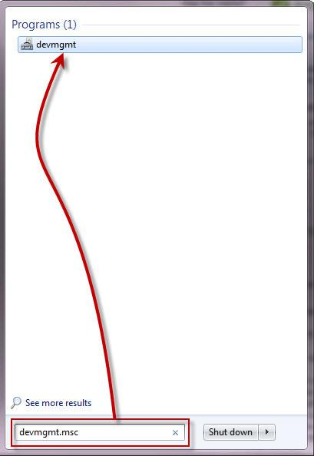

**(2)** Select the network adapter and right click on it,select **properties**.

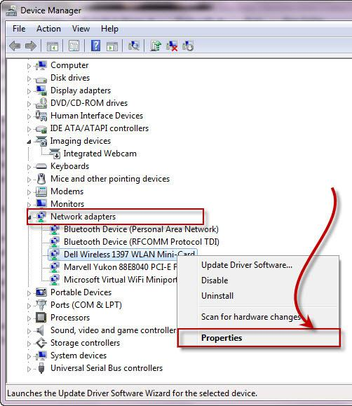

**(3)** Within the properties window, on the Driver tab, click on Update Driver button,After the installing of the updates restart the computer.

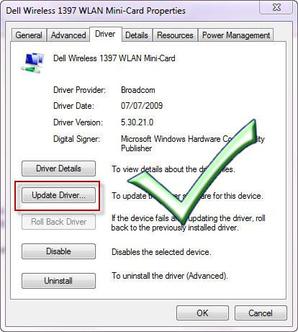

**(4)** Restart and then you are done!!

Read more at: [**http://windows7themes.net/en-us/how-to-fix-unidentified-network-no-internet-access/**](http://windows7themes.net/en-us/how-to-fix-unidentified-network-no-internet-access/) © windows7themes.net

11. From the same person who asked the question

I found a fix after lots and lots of tries, The link speed of my ethernet adapter was set to "1Gbps full-duplex". I changed it to "Auto-Negotiate". Tadaaa "Connected to Internet"

Thank you so much for giving me valuable ideas...

12. Windows 10 Support

**Method 1:**

Follow these steps for releasing and renewing IP address:  
  
a. Click “**Start**”.  
b. Type “**cmd**” in the Start search box and hit “**Enter**”.  
c. Enter the following commands:   
 **ipconfig /release  
ipconfig /renew**

**Method 2:**

**Step 1:**If you are using wireless connection, perform the steps provided. If not, go to next method.

**Uninstall and reinstall the wireless connection from device manager. Restart and update the drivers from manufacturer's website.**  
<http://windows.microsoft.com/en-US/windows7/Update-drivers-recommended-links>  
  
**Also refer:** <http://windows.microsoft.com/en-US/windows7/How-do-I-fix-network-adapter-problems>

**Step 2:**Uninstall and reinstall the Network adapter drivers from the device manager,follow these steps:

a. Start **Control Panel**, click **Hardware and Sound**, and then click **Device Manager.**

b. Expand the node that represents the type of device that you want to uninstall, right-click the device entry, and click**Uninstall**.

c. On the Confirm Device Removal dialog box, click OK to start the uninstall process.

d. When the uninstall process is complete, download the drivers from the manufactures website and install the drivers.

Note: You may have to download the drivers from a different computer and install the setup file by transferring the file using a flash drive.

e. After installing the drivers, install latest updates.

<http://windows.microsoft.com/en-US/windows7/Update-a-driver-for-hardware-that-isnt-working-properly>

13. 130 people found helpful

Try disabling the McAfee network agent service. Run > "msconfig" > Services. I disabled the mcafee network agent and the mcafee firewall core service.

14. 53 people found helpful

**Method 1: Update the network driver.**  
  
Steps to update network driver:  
  
1.    Click on start button.   
2.    In the search box type devmgmt.msc and then press enter.  
3.    Select the network card device and right click on it  
4.    Now select properties.  
5.    In the properties window, under Driver tab, click on Update Driver button.  
6.    After the installing the updates restart the computer.  
  
For more information visit: <http://windows.microsoft.com/en-us/windows7/Update-a-driver-for-hardware-that-isnt-working-properly>   
  
**Method 2: Try resetting the TCP/IP stack.**  
   
To reset the TCP/IP stack go to this article and either click on "Fix it for me" or follow the instructions to fix it yourself:<http://support.microsoft.com/kb/299357> .  
  
If still the same problem persists then try the next method.

15. 13 people found helpful

1. Take the LAN cable out

2. Restart and allow the WiFi to function or find nothing

3. Plug the LAN cable in. From this point on (until the next time you Restart), no "Unidentified Networt" (two conflicting Networks) and Internet Access.

16. “YOU ARE A GENIUS, MY FRIEND”

In Control Panel select Change Adapter Settings on LHS panel.  
Local Area Network Connection adapter icon is displayed.

Right click on the adapter icon and select "Properties" from pop up menu.

In resulting window, the list of installed protocols and services for this adapter are displayed.

Find and select "Internet Protocol Version 4 (TCP/IPv4) in the list then choose the properties button.

The properties window for the TCP/IPv4 protocol opens.

I have the buttons for "Obtain an IP address automatically" and "Obtain DNS server address automatically" selected.

Click the "Advanced" button to open up the Advance TCP/IP Settings window. It should show that you have DHCP enabled, however, in my case the default gateway address for my network was blank. I clicked the "Add" button beneath the Default Gateways box and added the gateway setting for my LAN here. That was it. As soon as I clicked the add button to add the gateway IP address I entered, it connected and I had full Internet access and no further problems connecting automatically after rebooting Win 7.

If you don't already know your LAN's gateway IP address, you can find it by going to the "Search programs and files" box on the Windows Start Menu (bottom left) and typing the command "cmd". Then hit enter to bring open a DOS box. In the DOS box window type the command "ipconfig" and hit enter on your keyboard. Look at the resulting list of numbers displayed beneath the section titled "Ethernet adapter Local Area Connection." The IP address of your LAN's Gateway is listed across from "Default Gateway."

I know that this fix will not apply to everyone, but it certainly was a quick one once I realized that even though I had DHCP enabled, my network adapter couldn't get internet access due to the fact it gouldn't automatically find the gateway address. Hope this helps!

17. User Solution

Try disabling local area connection

can be done by:

1) right click network icon in the right corner of the desktop

2) click Open Network and Sharing Center

3) one left click Change Adapter Settings

4) right click the name of your network adapter (mine its Local Area Connection)

5) select disable

6) after 10-20 sec

7) right click the same network adapter and click enable

            or

    double click the name of your network adapter which was previously disabled

18. Hmm…….